Navigating to printer settings

Depending on your windows version navigating to your printer settings are slightly different

For windows 10:

**Step 1:**

Navigate to the windows menu

* On the Taskbar in the bottom left of the screen click the windows icon

or

* Press the windows key on your keyboard



**Step 2:**

Navigate to the windows settings within the windows menu

* click the cog

or

* Search for settings in the search bar



**Step 3:**

Navigate to device settings

Click devices menu within the windows setting window

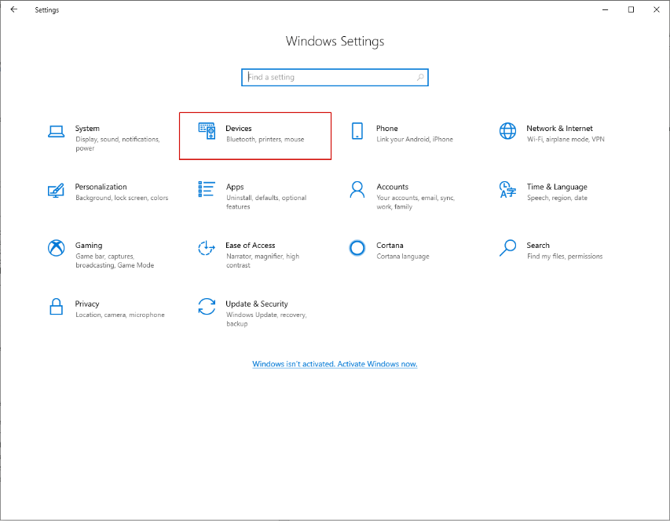

**Step 4:**

Enter the printer and scanner settings

Click the menu for printers in the left tool bar

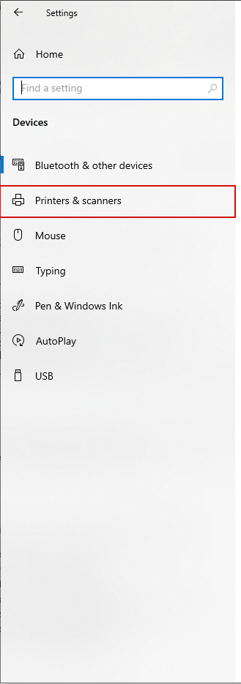

**Step 5:**

Open the menu to connect to a printer

Click the add a printer button and the top of the right window

Wait for a moment for your printer to appear

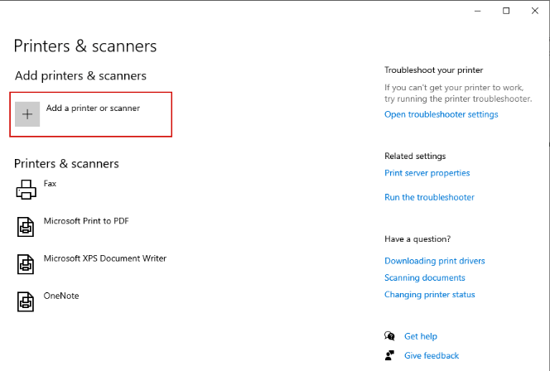

**Step 6:**

Assigning the device

If you printer is now visible click on your printer and add it

If it is not visible

Click the “the printer that I want is not listed” hyperlink that it below it

**Step 7:**

For printers not found

Adding a printer with any of the options will work but we will use TCP/IP method

**Step 8:**

Using either the devices name or IP address is possible

These are normally displayed on a sticker on the device if not

Follow this guide on how to find the IP address of the printer

<https://www.makeuseof.com/tag/find-ip-address-printer-4-methods-work/>

